Python project 2021

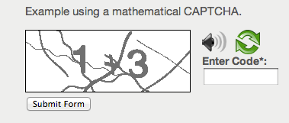

simple captcha using python

LOVELY PROFESSIONAL UNIVERSITY

PHAGWARA, PUNJAB

submitted by

Manjeet Singh

Registration number:

12020090

Signature of the student

Captcha

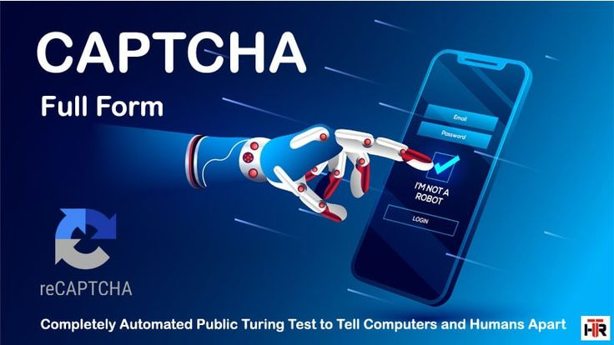

A [CAPTCHA](https://en.wikipedia.org/wiki/CAPTCHA) (Completely Automated Public Turing test to tell Computers and Humans Apart) is a test to determine whether the user is human or not.  
So, the task is to generate unique CAPTCHA every time and to tell whether the user is human or not by asking user to enter the same CAPTCHA as generated automatically and checking the user input with the generated CAPTCHA.

Project overview

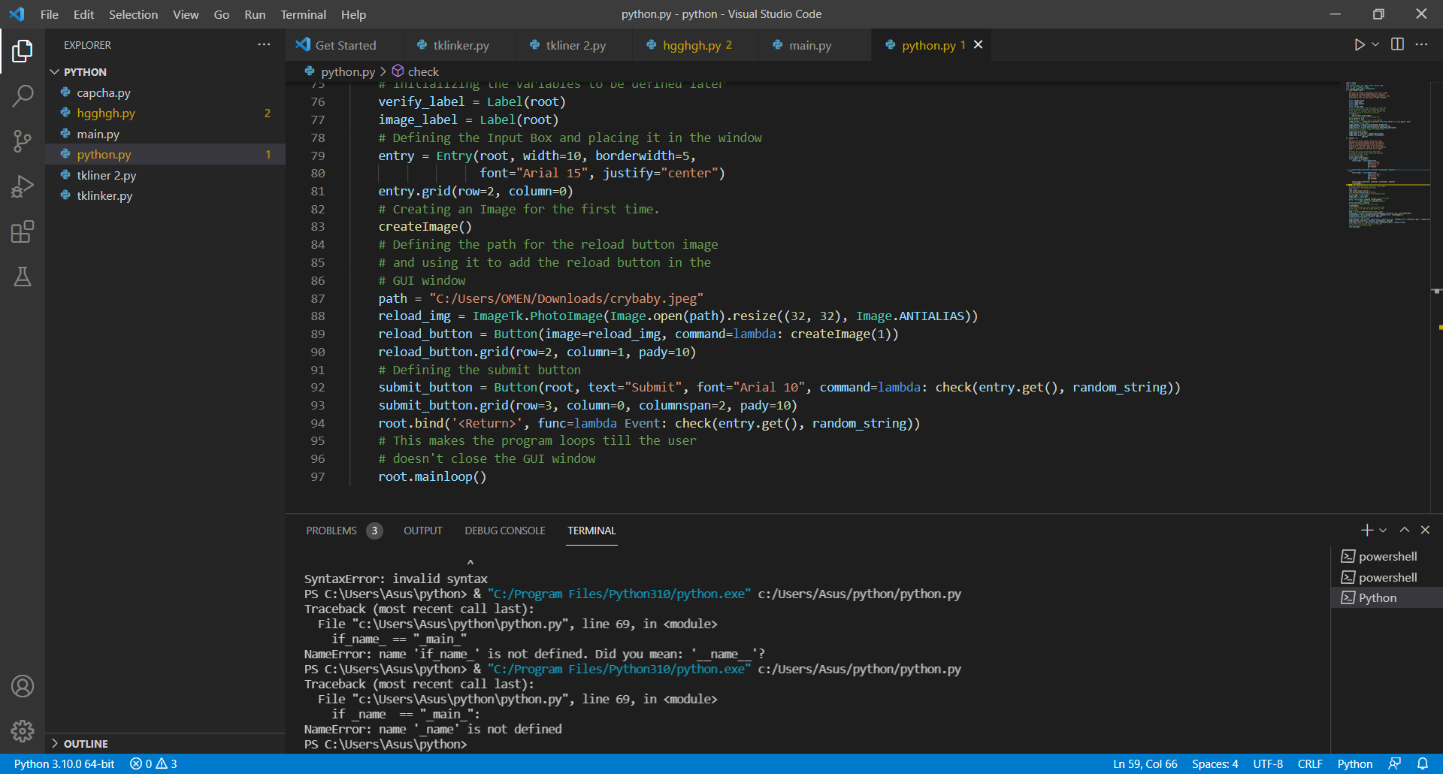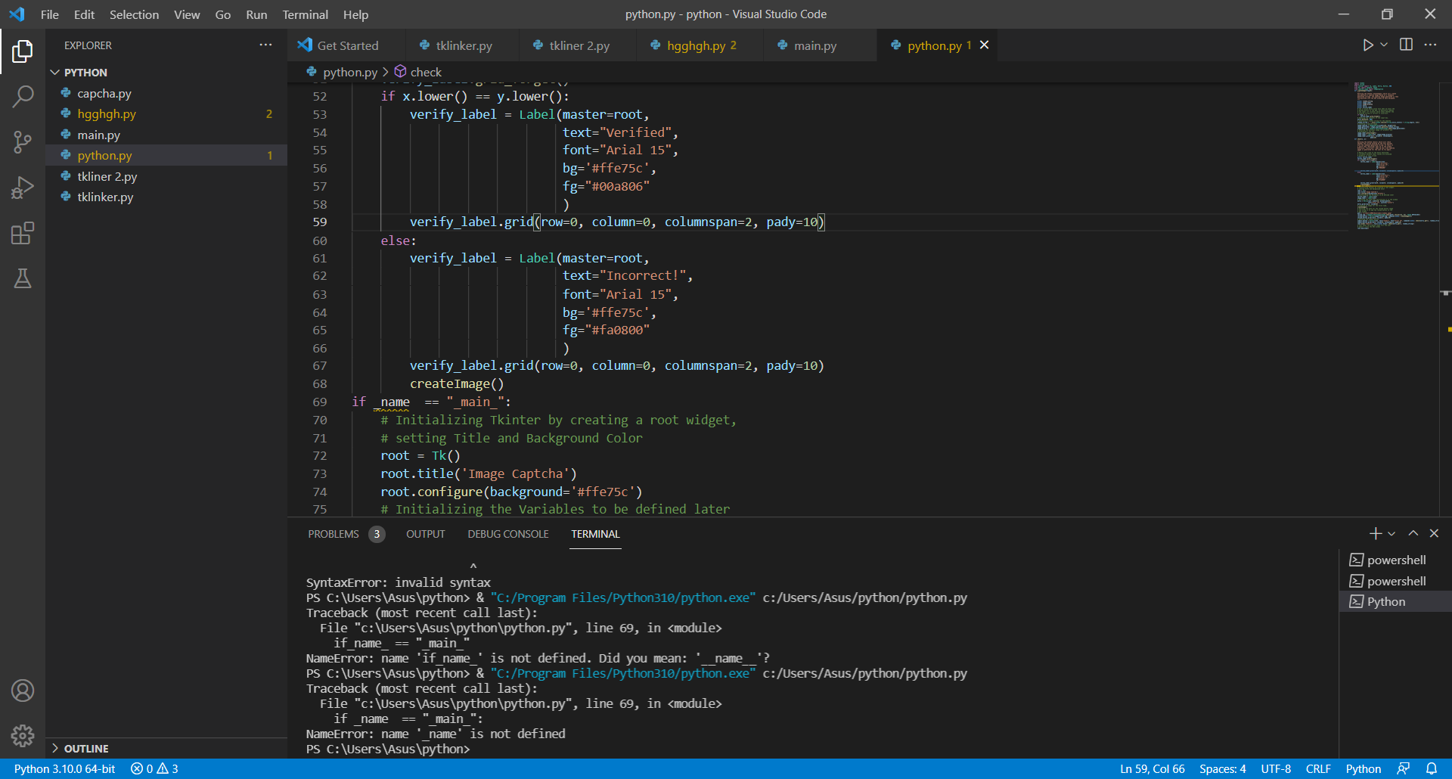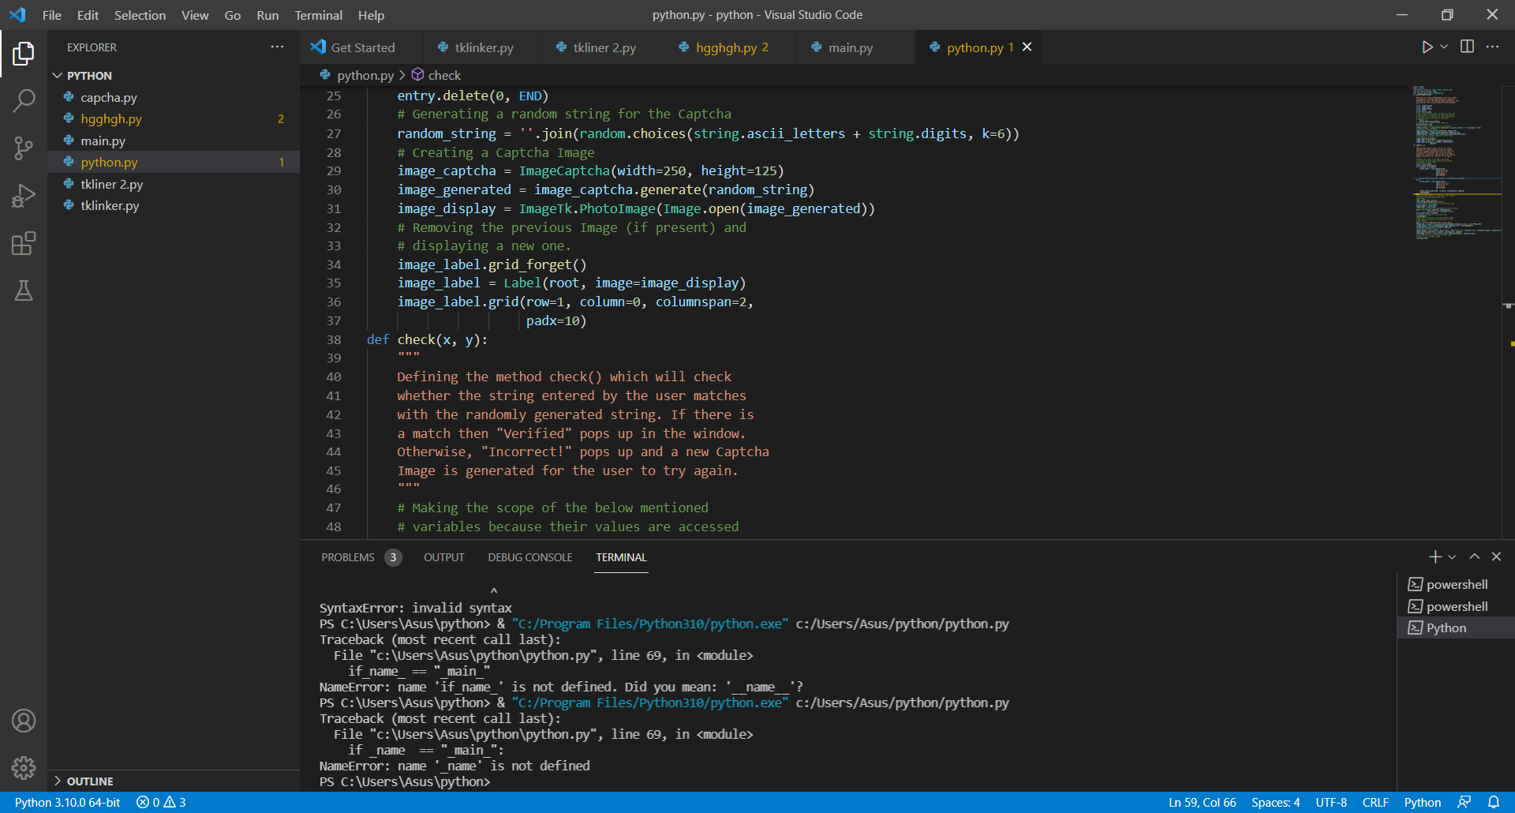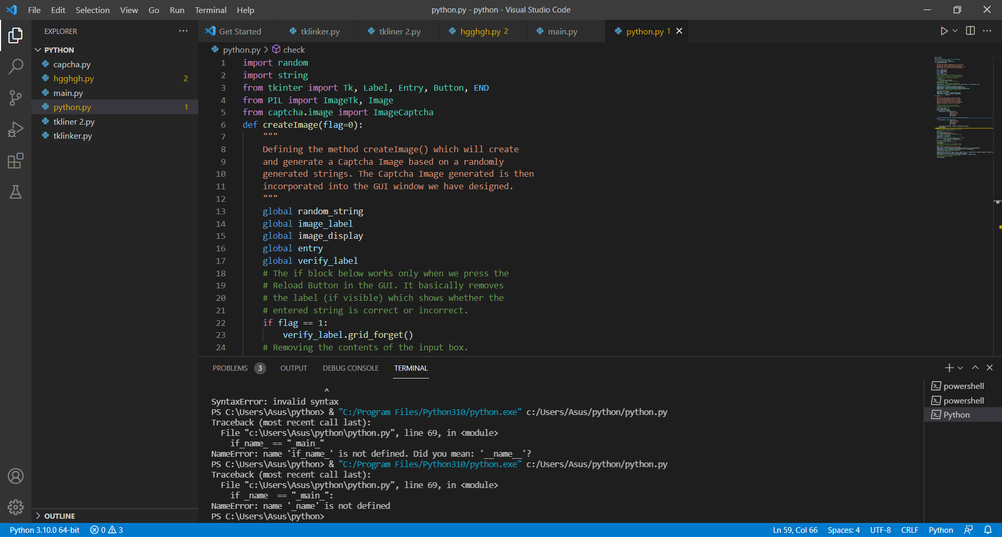

Final output

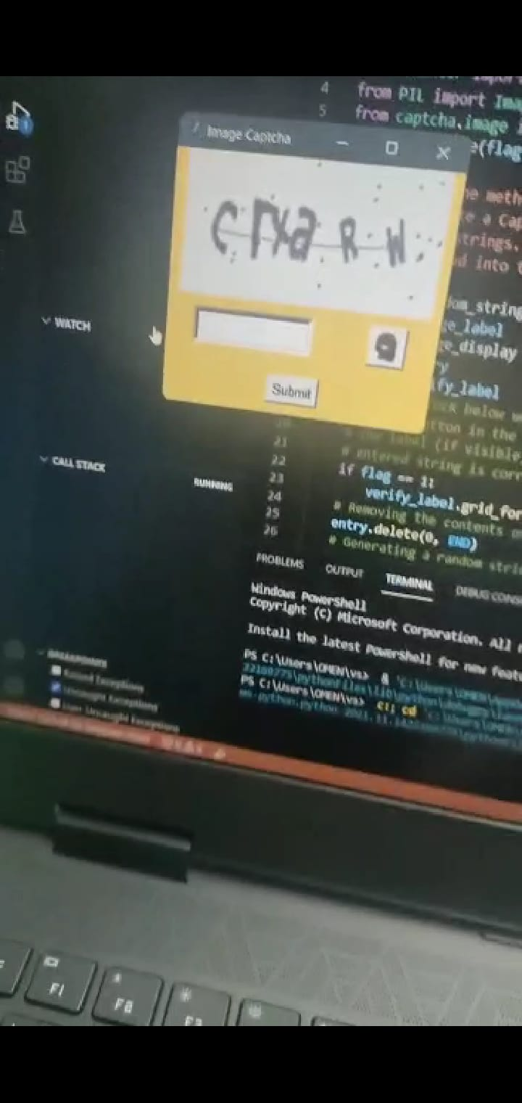

Project links

https://github.com/manjeetsachin/manjeetsachin

References



Thank you